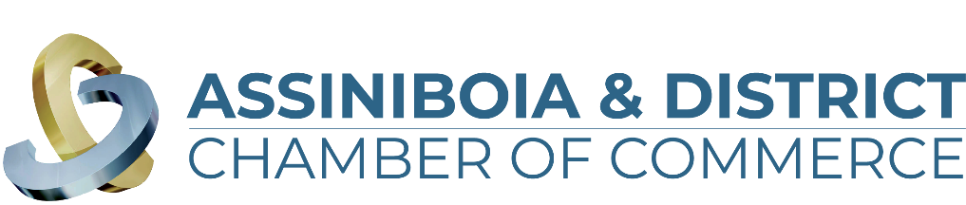

**Brewing in Business Excellence Awards 2024**

**“Community Involvement” Application**

The Community Involvement Award celebrates businesses who lead in creative ways and have a positive impact on the community. Showing evidence of clearly expressed and widely communicated strategy, focusing on actions which demonstrate a responsibility to enhance the social and natural environments in which they operate. From pitching in to helping neighbors to supporting your community, this is the award for you.

The business must meet the following criteria:

1. Be a for-profit business or not-for-profit with a substantial base of operations in the communities of Assiniboia, Limerick, Willow Bunch or within the surrounding Assiniboia & District Area.
2. Businesses must have a valid business license in the town of which they operate in. Not-for-profit must be registered through ISC or have recognized community contributions
3. Be in operation for a minimum of 1 year from date of applying.

*\*\*\*All information in this application is treated in a strictly confidential manner\*\*\**

Name of Company:   
Member of the Assiniboia & District Chamber of Commerce: Yes/No  
Contact Person (First & Last Name):   
Email Address:   
Phone Number:   
Company Website:   
Social Media Properties:   
Facebook:   
Instagram:   
Twitter:   
Linkedin:   
Youtube:

Questions:

1. In three sentences, please provide a brief description of your business including products and/or services you provide. What would you like people to know about your business (story, staff, products/services offered, your mandate, etc.). This information will be used in the video vignette at the Brewing in Business Excellence Award Event should your business be chosen as one of the finalists.
2. Does the company have a defined corporate objective and/or mandate in community involvement? (Limit of 500 words)
3. Describe the company’s involvement during the current reference year in one or more of the following fields. Please include the extent and type of activities as well as the impact on the community. (Limit of 500 words)

a) Arts & Culture

b) Amateur Sport

c) Education

d) Volunteer Community Groups

e) Other

1. Describe how your business has shown responsibility or demonstrated a leadership role within our community/communities? (Limit of 500 words)
2. Please note any extraordinary fact, strategy, or achievement that can be attributed to the business’ success that merits your company awarded the Community Involvement Award. (Limit of 500 words)
3. Please provide up to three (3) documents to support your application such as letters of articles or company reports, external performance reports, employee support, references, etc. (attach separate documents to the email): Please list all attachments.
4. Business Bio (60 words to describe your business in our event program if you are a finalist)

*Before you submit your application, please ensure you have included the following information (any missing information will result in your application being denied):*

* Application is complete. Responses are under the 500 word limit.
* Your business logo (vector format) is attached.
* Business Bio (Maximum 60 words) – Should you be chosen as a finalist this is used as a business description in the event program.
* Supporting documents (3 maximum)
* 5-10 Photos

Applications are due and close **September 24, 2024**, we cannot accept any late entries.

**October 2, 2024** judges will complete their final 5 finalists and businesses will be announced in each category.

On **October 18, 2024** we welcome you to attend our Brewing in Business Award ceremony.

Tickets are on sale and can be found on our website <https://assiniboiadistrictchamber.ca/>