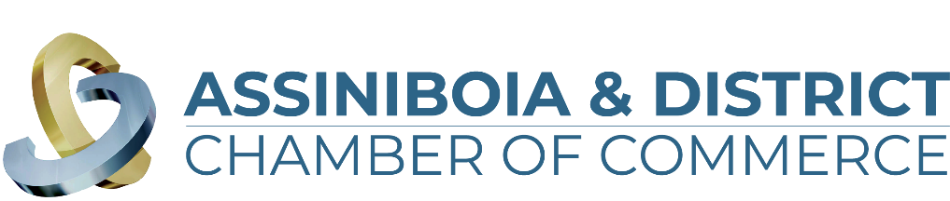

**Brewing in Business Excellence Awards 2024**

**“Customer Service” Application**

The Customer Service category celebrates businesses who built new connections with customers. Leveraging the new and often unprecedented circumstances, these businesses served customers in new and tailored ways. Whatever the specific circumstance, if you switched things up to better serve your customers, this category is for you!

The business must meet the following criteria:

1. Be a for-profit business with a substantial base of operations in the communities of Assiniboia, Limerick, Willow Bunch or within the surrounding Assiniboia & District area.
2. Have a valid business license in the Town they operate in
3. Showcase innovative service offerings

*\*\*\*All information in this application is treated in a strictly confidential manner\*\*\**

Name of Company:   
Member of the Assiniboia & District Chamber of Commerce: Yes/No  
Contact Person (First & Last Name):   
Email Address:   
Phone Number:   
Company Website:   
Social Media Properties:   
Facebook:   
Instagram:   
Twitter:   
Linkedin:   
Youtube:

Questions:

1. In three sentences, please provide a brief description of your business. What would you like people to know about your business (story, staff, products/services offered, your mandate, etc.)? This information will be used in the video vignette at the Brewing in Business Excellence Award Event should your business be chosen as one of the finalists.
2. How have you defined customer service within your corporate objectives? (Limit of 500 words)
3. What makes your customer service distinct and excellent? Provide examples of demonstrated service excellence. (Limit of 500 words)
4. Please describe what systems/processes are in place to measure customer satisfaction and ensure consistent excellence in customer service. (Limit of 500 words)
5. Describe how your customer service excellence strategy has increased your sales and profitability. (Limit of 500 words)
6. Please note any extraordinary fact, strategy, or achievement that can be attributed to the business’ success that merits your company being awarded the Customer Service Award. (Limit of 500 words)
7. Please provide up to three (3) documents to support your application such as letters of articles or company reports, external performance reports, employee support, references, etc. (attach separate documents to the email): Please list all attachments.
8. Business Bio (60 words to describe your business in our event program if you are a finalist)

*Before you submit your application, please ensure you have included the following information (any missing information will result in your application being denied):*

* Application is complete. Responses are under the 500 word limit.
* Your business logo (vector format) is attached.
* Business Bio (Maximum 60 words) – Should you be chosen as a finalist this is used as a business description in the event program.
* Supporting documents (3 maximum)
* 5-10 Photos

Applications are due and close **September 24, 2024**, we cannot accept any late entries.

**October 2, 2024** judges will complete their final 5 finalists and businesses will be announced in each category.

On **October 18, 2024** we welcome you to attend our Brewing in Business Award ceremony.

Tickets are on sale and can be found on our website <https://assiniboiadistrictchamber.ca/>