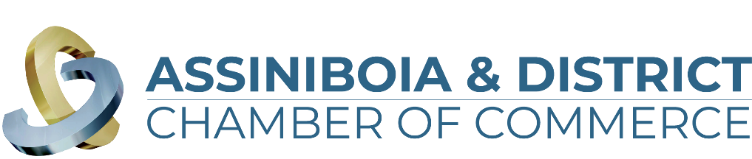

**Brewing in Business Excellence Awards 2024**

**“Impact Award” Application**

The Impact Award is presented to the not-for-profit organization that has contributed to the betterment of Assiniboia & District’s business landscape. Through innovative practices and transformative initiatives, the successful organization has played an impactful role in building a robust and vibrant network that contributes to making Assiniboia an ideal place to thrive.

The business must meet the following criteria:

1. Be a not-for-profit business with a substantial base of operations in the communities of Assiniboia, Limerick, Willow Bunch or within the surrounding Assiniboia & District Area
2. Has been in operation for a minimum of two years from applying

*\*\*\*All information in this application is treated in a strictly confidential manner\*\*\**

Name of Company:   
Member of the Assiniboia & District Chamber of Commerce: Yes/No  
Contact Person (First & Last Name):   
Email Address:   
Phone Number:   
Company Website:   
Social Media Properties:   
Facebook:   
Instagram:   
Twitter:   
Linkedin:   
Youtube:

Questions:

1. In three sentences (3), please provide a brief description of your organization including the services you provide.

*What would you like people to know about your organization (story, staff, products/services offered, your mandate, etc.). This information will be used in the video vignette at the Brewing in Business Excellence Award Event should your business be chosen as one of the finalists.

1. Describe the organization’s involvement during the current reference year in one or more of the following fields. Please include the extent and type of activities as well as the impact on the community. (Limit of 500 words)

a) Arts & Culture

b) Amateur Sport

c) Education

d) Volunteer Community Groups

e) Other

1. What is the long-term vision for the organization, to ensure sustainability and growth? (Limit 500 words)
2. Describe how your business has shown responsibility or demonstrated a leadership role within our community/communities? (Limit of 500 words)
3. Please note any extraordinary fact, strategy, or achievement that can be attributed to the business’ success that merits your company awarded the Impact Award (Limit of 500 words)
4. Please provide up to three (3) documents to support your application such as letters of articles or organization reports, external testimonies, letter of recommendation, references, etc. (attach separate documents to the email)
5. Business Bio (60 words to describe your business in our event program if you are a finalist)

*Before you submit your application, please ensure you have included the following information (any missing information will result in your application being denied):*

* Application is complete. Responses are under the 500 word limit.
* Your business logo (vector format) is attached.
* Business Bio (Maximum 60 words) – Should you be chosen as a finalist this is used as a business description in the event program.
* Supporting documents (3 maximum)
* 5-10 Photos

Applications are due and close **September 24, 2024**, we cannot accept any late entries.

**October 2, 2024** judges will complete their final 5 finalists and businesses will be announced in each category.

On **October 18, 2024** we welcome you to attend our Brewing in Business Award ceremony.

Tickets are on sale and can be found on our website <https://assiniboiadistrictchamber.ca/>