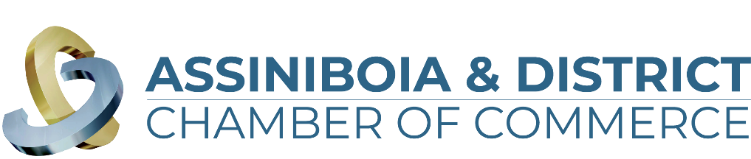

**Brewing in Business Excellence Awards 2024**

**“NEW BUSINESS” Application**

The New Business category recognizes businesses that have been in operation since December 2020 and have strategies and plans to achieve business growth. These entrepreneurs took the leap and have shown they have what it takes to make it!

The business must meet the following criteria:

1. Be a for-profit business with a substantial base of operations in the communities of Assiniboia, Limerick, Willow Bunch or within the surrounding Assiniboia & District Area
2. Have a valid business license in the town of which they operate in.
3. Has been in operation as of December 31, 2020.

*\*\*\*All information in this application is treated in a strictly confidential manner\*\*\**

Name of Company:   
Member of the Assiniboia & District Chamber of Commerce: Yes/No  
Contact Person (First & Last Name):   
Email Address:   
Phone Number:   
Company Website:   
Social Media Properties:   
Facebook:   
Instagram:   
Twitter:   
Linkedin:   
Youtube:

Questions:

1. In three sentences (3), please provide a brief description of your business including products and/or services you provide.

*What would you like people to know about your business (story, staff, products/services offered, your mandate, etc.). This information will be used in the video vignette at the Brewing in Business Excellence Award Event should your business be chosen as one of the finalists.

1. What was the origin of the business idea? (Limit of 500 words)
2. How has your company demonstrated excellence in decision making/performance? (Limit of 500 words)
3. What were the new venture’s original objectives, including sales? How many of these objectives have been achieved and how? (e.g., customer response, financial results, etc.) (Limit of 500 words)
4. What is the long-term vision for the company, to ensure sustainability and growth? (Limit 500 words)
5. Please note any extraordinary fact, strategy, or achievement that can be attributed to the business’ success that merits your company awarded the New Business Award. (Limit of 500 words)
6. Please provide up to three (3) documents to support your application such as letters of articles or company reports, external performance reports, employee support, references, etc. (attach separate documents to the email)
7. Business Bio (60 words to describe your business in our event program if you are a finalist)

*Before you submit your application, please ensure you have included the following information (any missing information will result in your application being denied):*

* Application is complete. Responses are under the 500 word limit.
* Your business logo (vector format) is attached.
* Business Bio (Maximum 60 words) – Should you be chosen as a finalist this is used as a business description in the event program.
* Supporting documents (3 maximum)
* 5-10 Photos

Applications are due and close **September 24, 2024**, we cannot accept any late entries.

**October 2, 2024** judges will complete their final 5 finalists and businesses will be announced in each category.

On **October 18, 2024** we welcome you to attend our Brewing in Business Award ceremony.

Tickets are on sale and can be found on our website <https://assiniboiadistrictchamber.ca/>